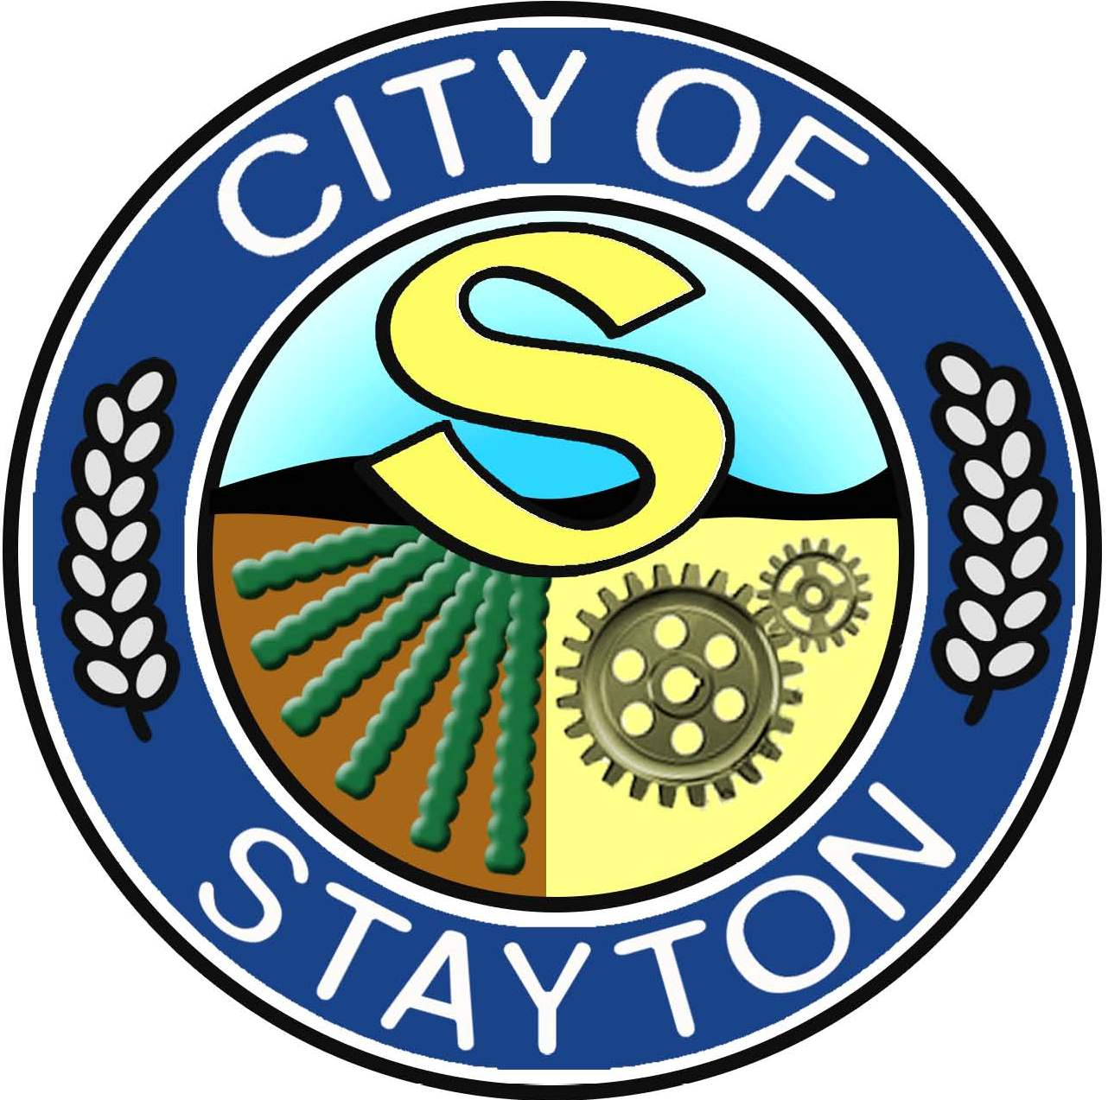

CITY OF STAYTON PUBLIC ARTS COMMISSION

Thursday, May 23rd, 2024
Public Works Conference Room

ROLL CALL

Present: Mark Kronquist
Nick Raba
Amy Watts

Absent: N/A

Staff: Jennifer Siciliano, Community & Economic Development Director
Windy Cudd, Office Specialist (Minutes)

Guest(s): None

CALL TO ORDER: Siciliano called the meeting to order at 6:08pm.

INTRODUCTION AND RESPONSIBILITIES OF THE PUBLIC ARTS BOARD: Siciliano introduced the Public Arts Commission to the members of the group. Detailing out:
- Establishment
- Membership, Appointment, Terms and Organization
- Responsibilities
- Standards and Rules
- Funding; Establishment of Public Art Fund
- Process for Acquiring Public Art
- Guidelines for Recommendation by the Commission

ELECTION OF OFFICERS:
Chair: Mark Kronquist
Vice-Chair: Nick Raba

PRESENTATIONS / COMMENTS FROM THE PUBLIC: None

REVIEW AND APPROVAL OF MINUTES: 1st Meeting, No Minutes

FUTURE AGENDA-

ADJOURN Meeting was adjourned at 7:39pm.
NEXT MEETING DATE- June 20th, 2024 @ 6:00pm, at Public Works Conference Room

